

Draw It or Lose It

# **CS 230 Project Software Design Template**

Version 1.0

## Table of Contents

**CS 230 Project Software Design Template**1

**Table of Contents**2

**Document Revision History**2

**Executive Summary**3

**Design Constraints**3

**System Architecture View**3

**Domain Model**3

**Evaluation**3

**Recommendations**5

## Document Revision History

| Version | Date | Author | Comments |
| --- | --- | --- | --- |
| 1.0 | 11/14/2020 | Christian Rojas | Version 1.0: Created Design Template, Went over executive summary, design constraints, System Architecture, domain model and evaluation. |

## Executive Summary

The Gaming Room would like to set up a web-based environment for their game Draw It or Lose It. The Gaming Room team does not have the means to set up the environment and will need my help developing the environment. The client requires multiple teams with multiple players, the game and team names must be unique, so allowing players to select their team name is a must as well as validating whether the selected name is in use. Unique identifiers for each instance of a game, team, or player will allow for only one instance of the game to exist at any given time.

## Design Constraints

* There are a few constraints when it comes to building a game in a web-based environment. One being that web-based games are not going to be as robust as a game that is hosted on its own engine. This constraint will limit just how large the game can be.
* Another constraint is hardware. The client wants a program that can run on a large range of hardware, from mobile to desktop. The issue with such a large range of hardware means that the team will need to work longer to optimize the software for each level of hardware (i.e. mobile vs desktop).
* Another constraint is building a framework that allows multiple unique teams with multiple unique players to play at once on a single instance. This uses a lot of bandwidth and can create budgetary constraints.

## System Architecture View

Please note: There is nothing required here for these projects, but this section serves as a reminder that describing the system and subsystem architecture present in the application, including physical components or tiers, may be required for other projects. A logical topology of the communication and storage aspects is also necessary to understand the overall architecture and should be provided.

## Domain Model

* Classes Game, Team, and Player all have ‘is a’ relationship to Entity.
  + This means that the three classes are all entities.
  + They are also inherited from the Super Entity Class
* Team and Player have a ‘has a’ relationship.
  + Class Team has players, as well as Game has teams.
  + GameService also has teams.
* In the UML Diagram, the above-mentioned can be represented by aggregation.
  + This means that the ‘has-a’ relationship is an instance of one class referring to the instance of another class.
  + Example: In soccer (Entity) you have matches (Game) between two teams (Team) with eleven players(Player) each.

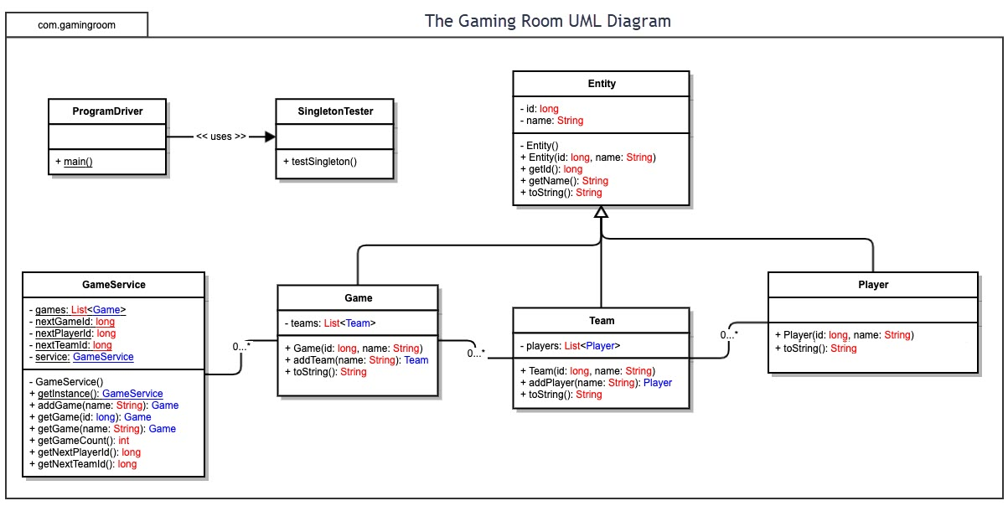

## 

## Evaluation

| **Development Requirements** | **Mac** | **Linux** | **Windows** | **Mobile Devices** |
| --- | --- | --- | --- | --- |
| **Server Side** | Mac is very flexible, with terminal commands that can configure server access and make changes. | Linux allows for flexibility through the terminal like Mac; However, Linux is more cost effective than Mac and more flexible on the hardware side, as it can run on almost any machine. | Easiest to setup in terms of experience and time. The cost can vary. Compared to Mac, Windows security is not as good. | Server should be in a fixed location. Mobile devices are also smaller and will feature lower specifications than other servers. |
| **Client Side** | Costs associated are higher than Windows. Mac requires a higher level of expertise. Mac also has the edge up on security. | Very minimum cost with Linux.  Linux requires a large amount of expertise and time. | Windows costs are lower than Mac. Lowest required expertise compared to Mac or Linux. | Extremely flexible. Allows client to check in at any time. Mobile devices are harder to implement. |
| **Development Tools** | Common languages include JavaScript, HTML, and CSS for a web application. Other languages include Java, C++, and Python with their included libraries.  Tools: Visual Studio, GitHub, and PyCharm.  All these languages and tools are available on all operating systems. | Common languages include JavaScript, HTML, and CSS for a web application. Other languages include Java, C++, and Python with their included libraries.  Tools: Visual Studio, GitHub, and PyCharm.  All these languages and tools are available on all operating systems. | Common languages include JavaScript, HTML, and CSS for a web application. Other languages include Java, C++, and Python with their included libraries.  Tools: Visual Studio, GitHub, and PyCharm.  All these languages and tools are available on all operating systems. | Common languages include JavaScript, HTML, and CSS for a web application. Other languages include Java, C++, and Python with their included libraries.  Tools: Visual Studio, GitHub, and PyCharm.  All these languages and tools are available on all operating systems. |

## Recommendations

Analyze the characteristics of and techniques specific to various systems architectures and make a recommendation to The Gaming Room. Specifically, address the following:

1. **Operating Platform**: For the Draw It or Lose It application, Windows Server is recommended as the operating system. Windows is widely regarded as the best platform for game development because of the wide availability of software and language packages, its variety is a very favorable. Another benefit of Windows OS is the cost, Windows is more cost effective than competing Operating Platforms and requires a lower expertise.
2. **Operating Systems Architectures**: Using Windows Server will provide applications to use a GUI that is available to all windows-based applications. PowerShell allows for direct maintenance of the machine. Windows also allows for developers to access a wide range of system resources, including memory and file management which allow for the user to manipulate the memory to spec. Also, multi-processor scheduling will assign percentages of the processing power to tasks from a ready state to a running state. Multi-processor scheduling allows for optimal performance on the machine.
3. **Storage Management**: With Windows Server 10 the client has great control over their storage using Storage Sense. The client can designate save locations for game files, as well as get a proper look into what files are using the most storage, this allows the user to ensure the machine has adequate storage.
4. **Memory Management**: Using a region-based allocator as opposed to a general allocator is recommended. A region-based allocator will allow achieve better performance due to its smaller memory management cost. Windows 10 Server uses RAM, physical and virtual spaces to allow 2 to 4 gigabytes of memory. The system will move pages of virtual address space to the hard drive to free RAM for additional use.
5. **Distributed Systems and Networks**: Because this game will run on multiple platforms, the developers must keep in mind that the program must keep in mind things like aspect ratio, audio and video codecs and other things that are all unique to each operating system. Networking support in a distributed system is a good way to distribute the software and allow for use on multiple operating systems. Distributed Systems and Networks allows for the user to communicate with different servers. This is essentially a server-client relationship. The server is able to efficiently divide tasks and process them among both the server and client.
6. **Security**: Security features are critical to protect sensitive user information. Windows Server has built in security features to protect user data. Windows Server has a built-in protection against memory corruption attacks. Also, shielded virtual machines is a feature that is offered in Windows Server, Shielded VM blocks all unauthorized users from accessing contents within the server. Another feature, Windows Defender allows the control of what applications can run on the server as well as detecting and blocking malware.